Jenkins Assignment No:2
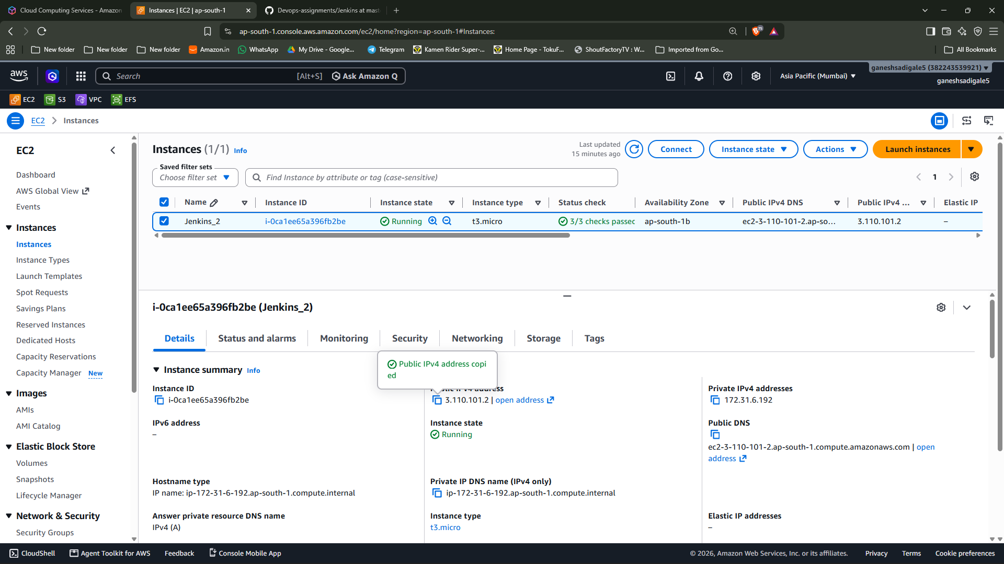

Step1: Created an EC2 instance named “Jenkins_2” and connected a security group with port 22, 80 and 8080 allowed in inbound rules

Step2: Used putty to login into the instance

Step3: Downloaded Java-21 in the EC2

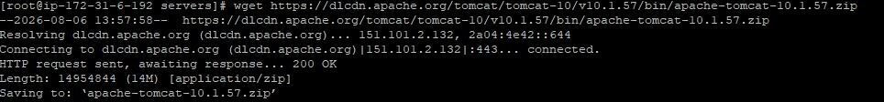
Step4: Downloaded Tomcat 10.1.57 zip file and unzip it

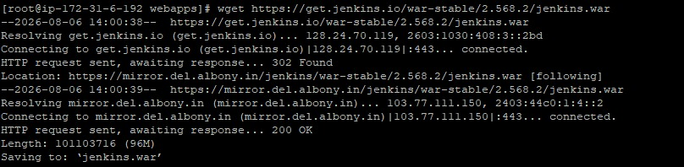
Step5: Downloaded Jenkins and used “./startup.sh” to start it

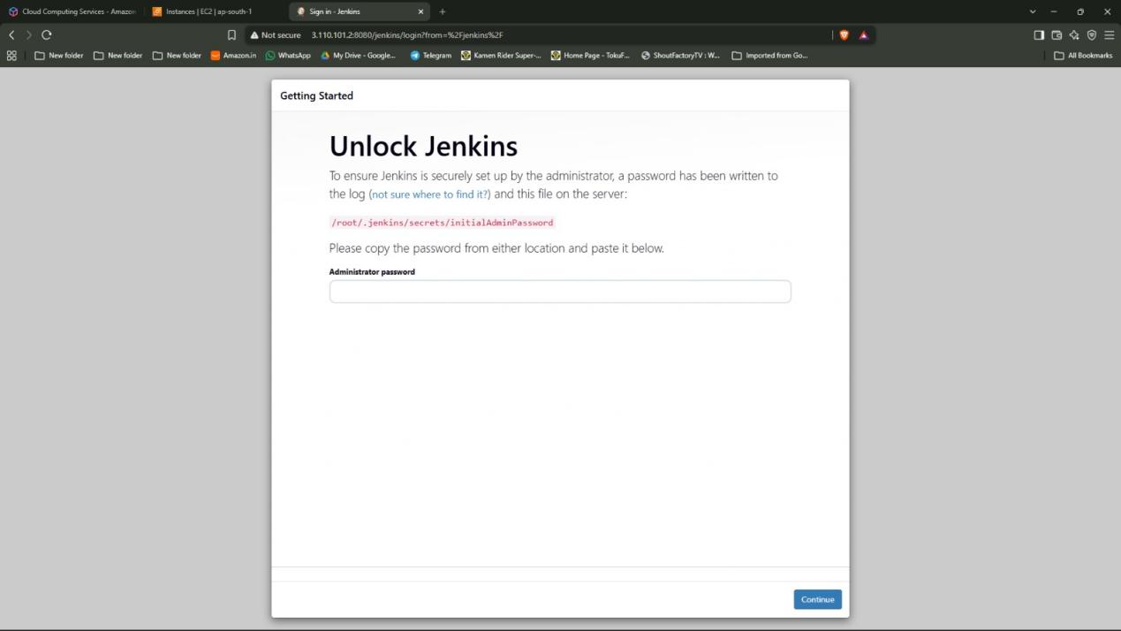

Step6: Used Public ip as “http://<public-ip>:8080/jenkins” to access Jenkins UI.
there I first had to put the initial admin password.

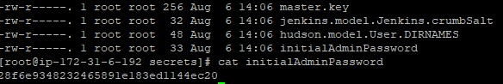
The password was found in “ /roots/.jenkins/secrets” name of the file was “initialadminpassword” which I used cat on

Step7: After doing that I created a admin account and did the setup for jenkins

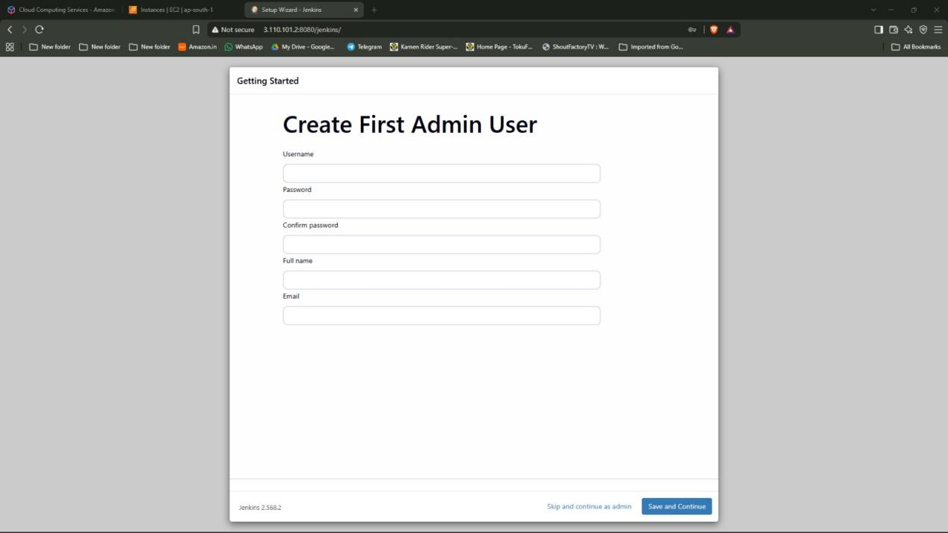

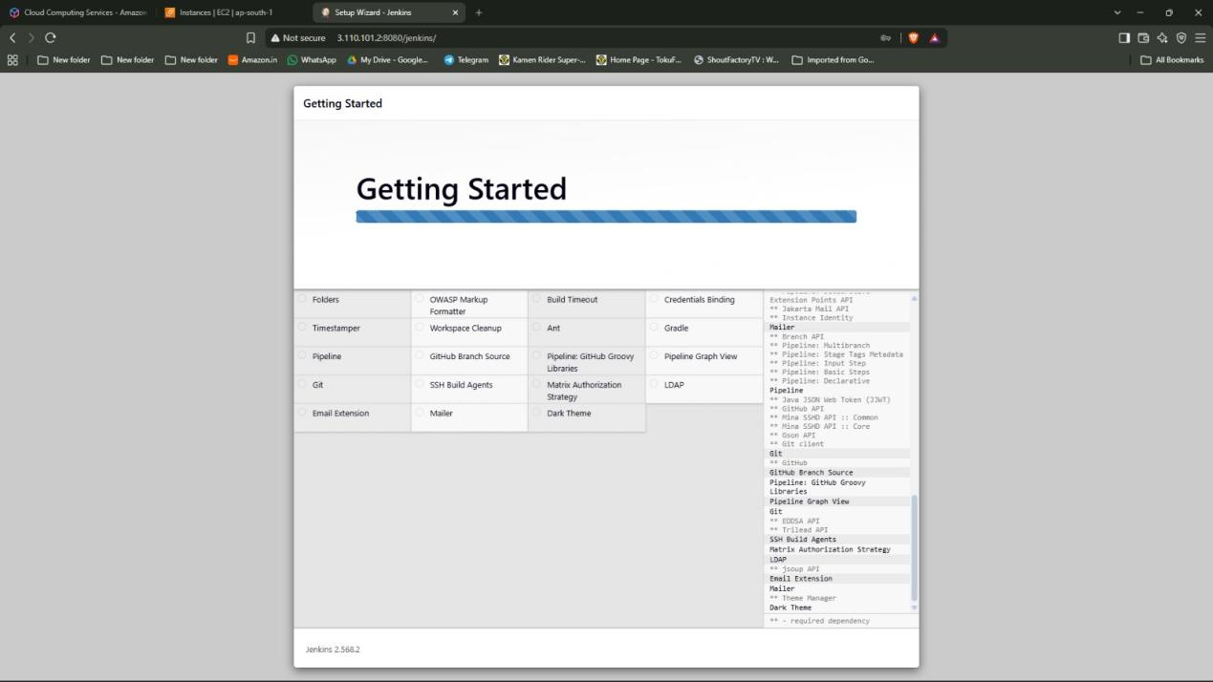

Step8: Selected the option “Create a job”

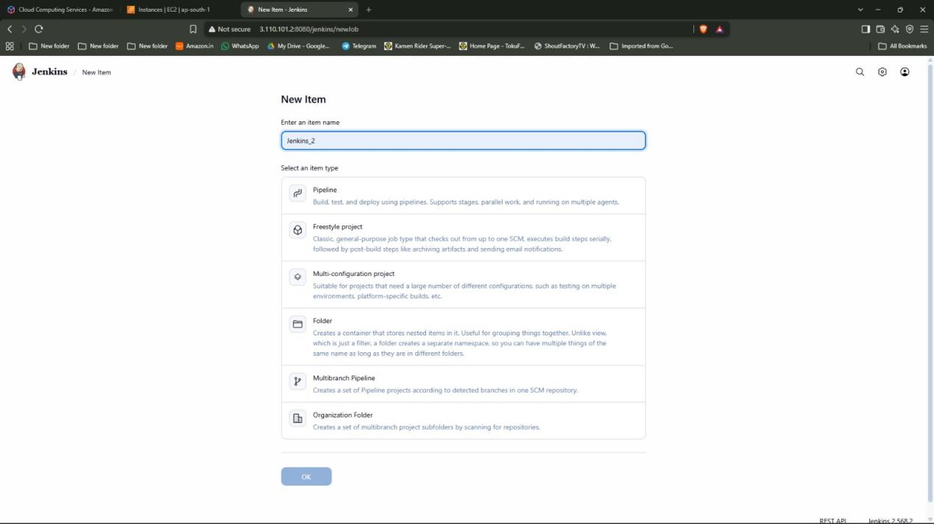

Step9:Entered the item name as “Jenkins_2”. Selected the option “Freestyle project”

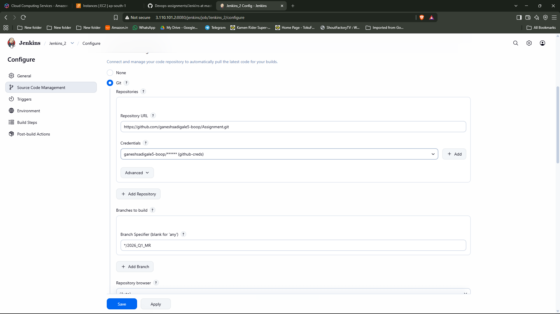
Step10: Selected the “Git” option in Source code management copied the git url of the private repository and gave credentials to access it (as the repository is private I used PAT) and then specified the branch.

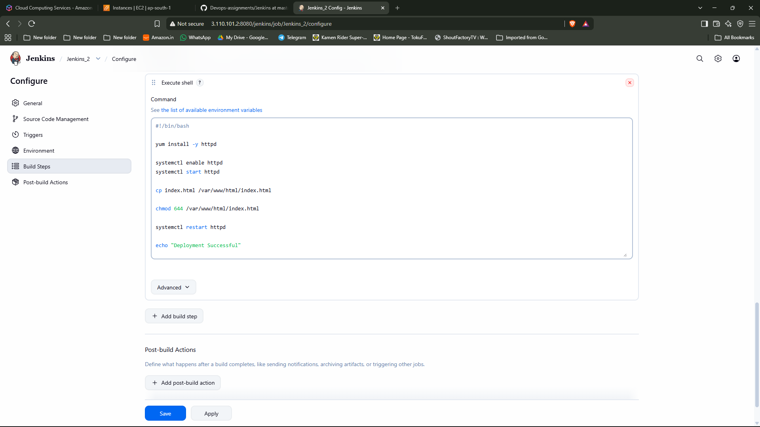

Step11: Selected the “Execute Shell” option in build and wrote the script then selected the option “Build now” which built the file

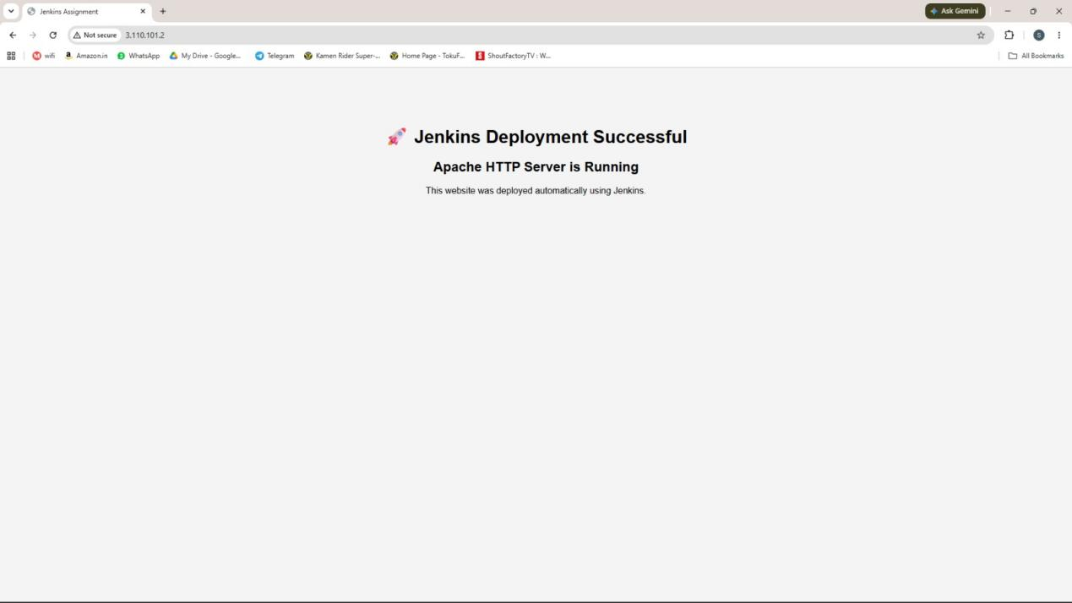

Step12: Used Public ip as “http://<public-ip>” to access the website

